EXPERIMENT 8 CO-space
Harsha Vardhan
2400040454
Create VR 3D Tour by using Co-spaces

Aim:

The main objective of this experiment is to create a virtual reality 3D environment using Cospaces.

SOFTWARE REQUIRED:
Cospaces

APPARATUS REQUIRED:

Name of the Component | No of Units
Computer | 1
Internet network | 1

Procedure:

Setting up your account

- Go to cospaces.io and click Register to create your CoSpaces Edu account.

Create an account as a teacher.
3. Define your login details or sign inwith Apple, Google or Microsoft.If you haven’t used your Pro trial yet, click Activate trial.
Creating a first CoSpace

To start creating, go to CoSpaces.
You can start by exploring the Welcome CoSpace to get familiar with the basics. When you’re ready to create your first CoSpace, click Create CoSpace.

Your first step is to choose a scene to build in. You’ll be able to add all the scenes you want later!
You can build in a 3D environment of your choice. These scenes can be viewed in VR and AR.
You can also build upon a 360° image that you choose. These scenes can be viewed in VR.

Setting up a first scene
To create your first scene, start by selecting the 3D environment or the 360° image you would like to use as the background.
To choose an environment, click Environment at the bottom-left. If you’re creating inside of a 3D environment, click Edit and choose one of the predefined environments.
If you’re creating inside of a 3D environment, click Edit and choose one of the predefined environments.
You can then customize your scene further using Filters.

The 3D camera

The 3D camera at the center of your scene lets you define the perspective from which your scene can be explored. If needed, you can find the 3D camera object in the Library’s Special category.
You can also choose from several camera movements to change the way in which you experience your creation. To change the camera movement, click Camera.

Fixed
The camera is fixed to a certain position and you look around your scene using your mouse or keyboard arrows.

Walk
You walk in the scene using your keyboard arrows or WASD keys. You use your mouse to look around.

Fly
You fly above the scene using your keyboard arrows or WASD and QE keys to change height. You use your mouse to look around.

Orbit
You move in a circle on a zone that you define around the center of your scene using your mouse, keyboard arrows or WASD keys.

The CoSpaces Edu Library
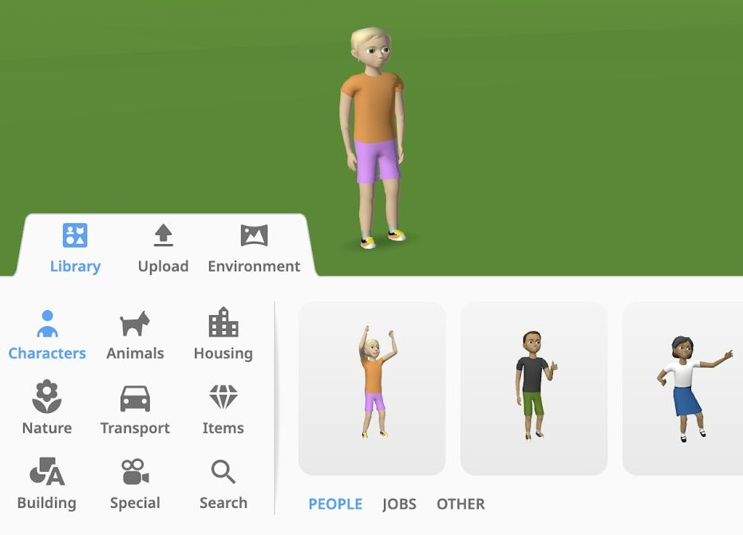
Time to start creating! In the Library, you’ll find many 3D objects, which you can simply drag and drop onto the stage. Objects from the Library can be moved, rotated or resized, coded, and edited to change their colors.

Building blocks are available in the Building category. These primitive shapes let you create anything you want in 3D

Uploading external files
You can upload various external files
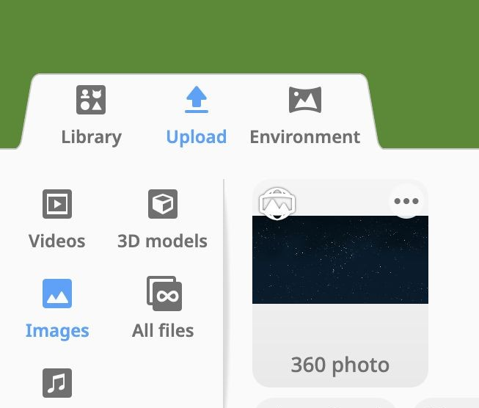
to use in your creations. To upload an external file, click Upload. You can upload: images including GIFs and 360° images, videos, 3D models (in .obj, .stl, .fbx), sound files. CoSpaces Edu Basic is limited to 10 upload.

If you’re building upon a 360° image, click Edit and upload any 360° image you like.

PROGRAM:

CoBlocks
CoBlocks is a visual coding language that lets you simply drag and drop CoBlocks (blocks of code) to program your CoSpace. A CoBlock represents a snippet of code, or statement, which tells CoSpaces Edu to do something like starting a specific action in your scene.
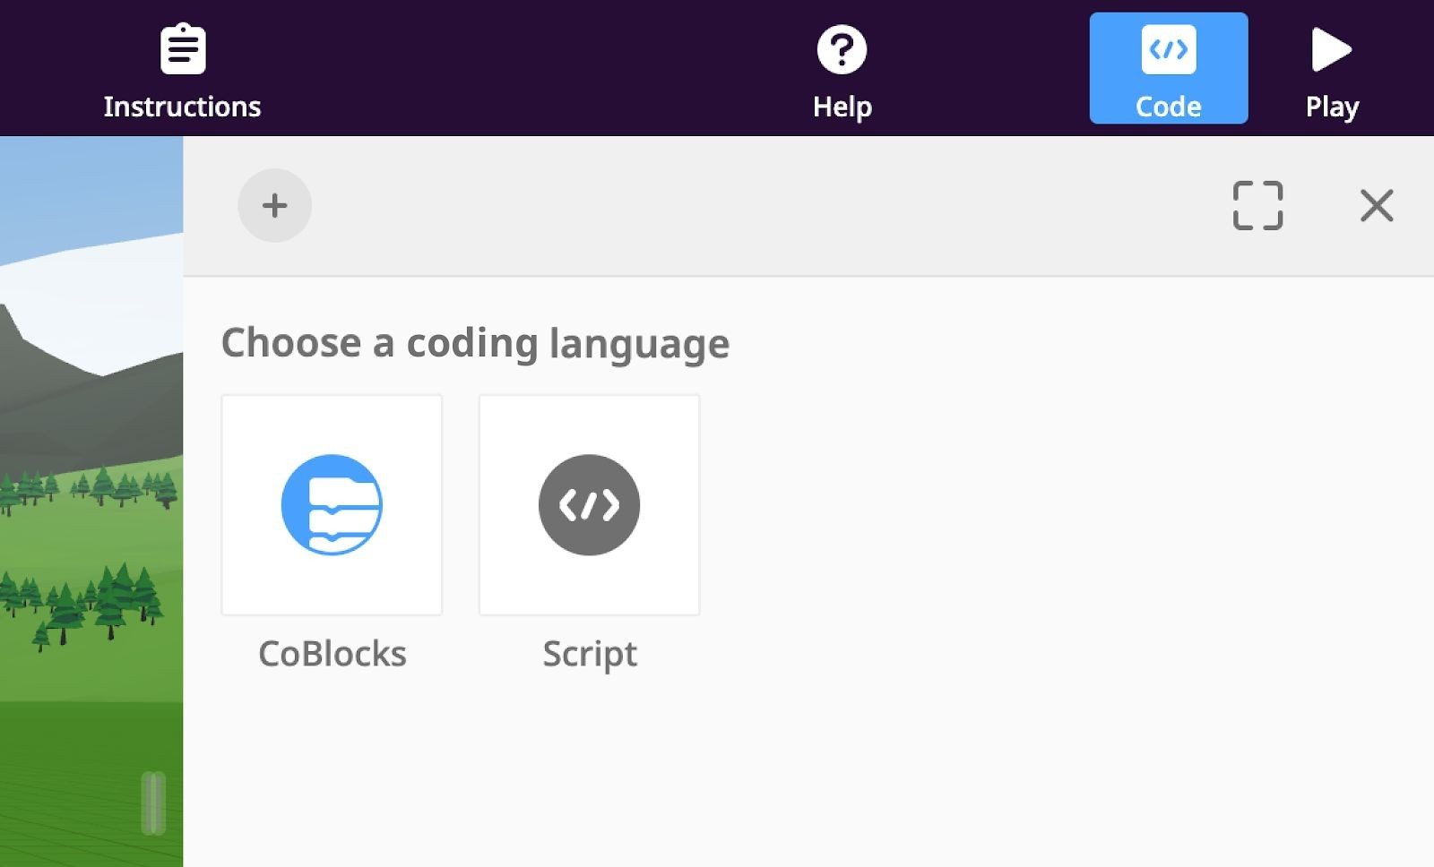
You can find the Code icon in the top-right toolbar.
To open the CoBlocks coding editor, click the CoBlocks icon.

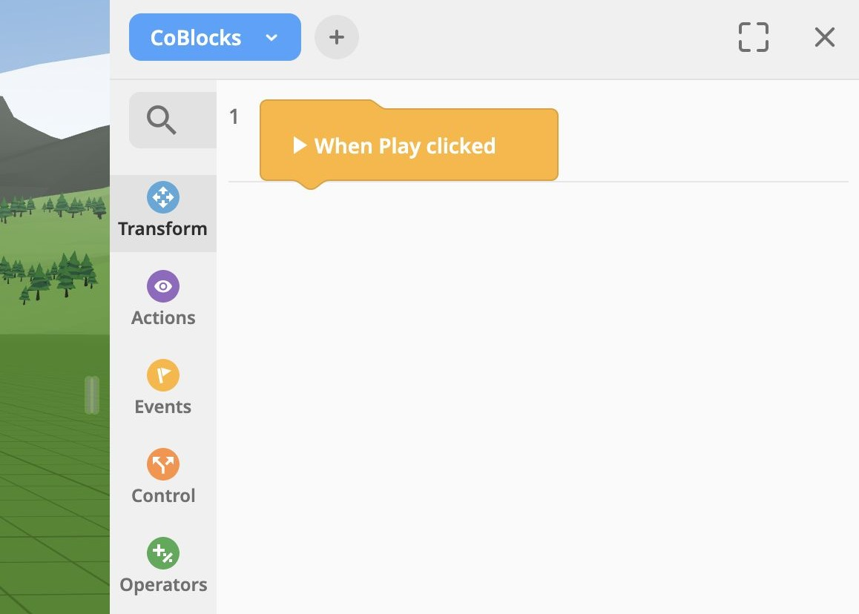
The empty space on the right side is the
CoBlocks workspace.

The list of CoBlocks on the left side is the
CoBlocks toolbox.

To program an item with CoBlocks, enable its use in CoBlocks.
To do this, select the object you would like to use in your code, click Code, and enable Use in CoBlocks.
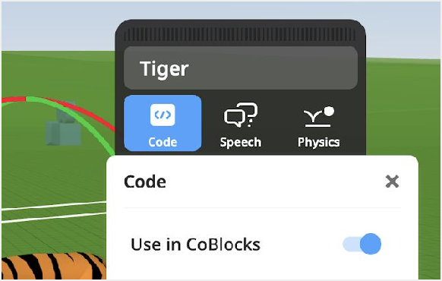

There are 2 main types of CoBlocks: Expression and Statement CoBlocks:

Statement CoBlocks
Statement CoBlocks often perform a specific action. For example, you can make an item talk, using the say CoBlock.

Expression CoBlocks
Expression CoBlocks contain values. These values can be:

- Colors (red, green, blue)
- Numbers like 5 and 0.25
- Strings like "Hi there!"
- Other items in the scene

Expression CoBlocks can be recognized by their round shape and are always placed into other CoBlocks:

Check out the CoBlocks reference guide to learn more about coding with CoBlocks.

RESULT:

